Open Data

Visualization

with

Carto

**Data from Malaga town hall website**

**(horse carriage stops and water fountains)**

**Step 1**: <https://datosabiertos.malaga.eu/>

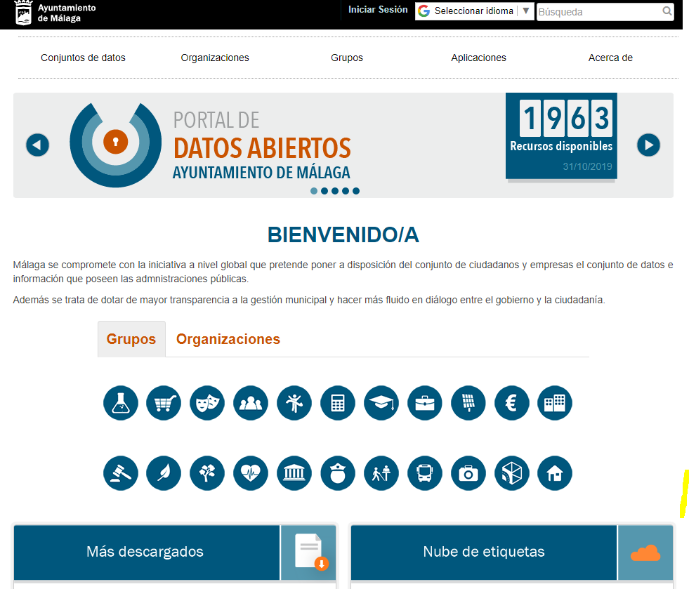

**Step 2**: Select data sources

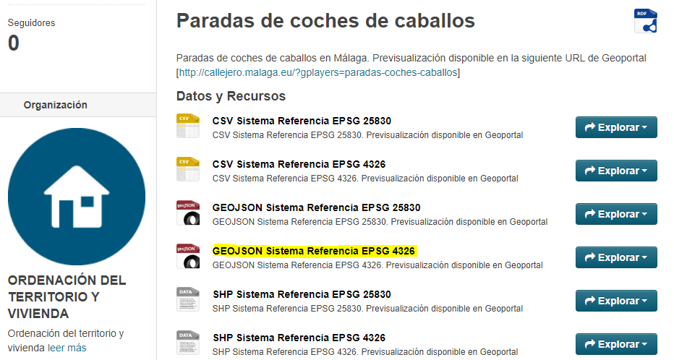

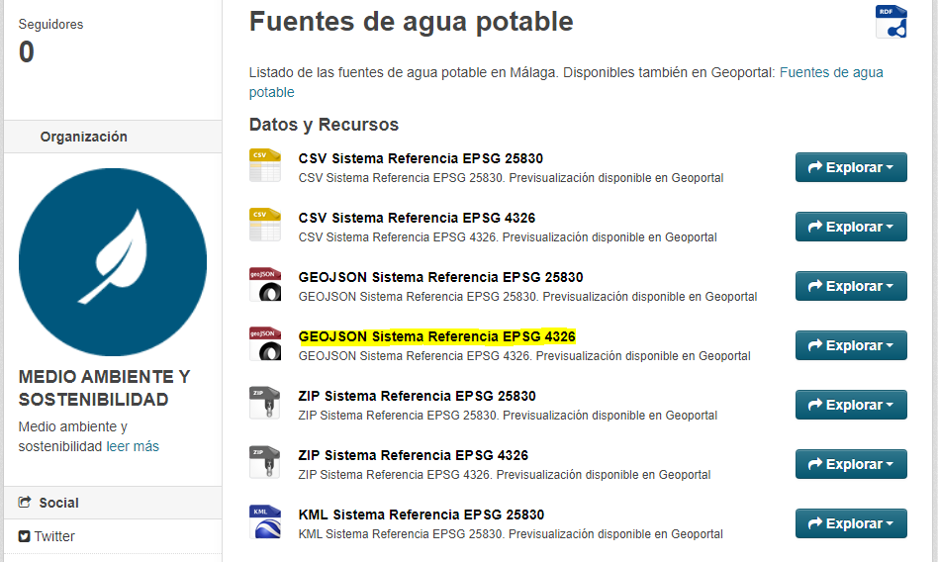

**Step 3**: Import data sources in www.carto.com



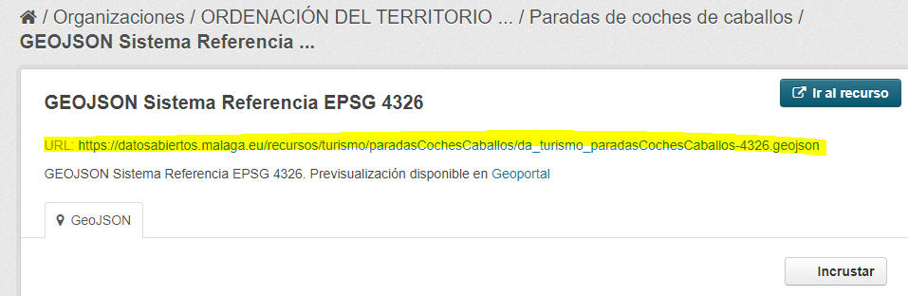

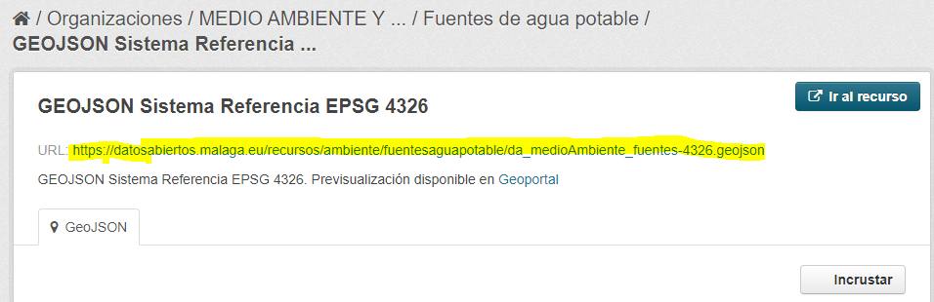

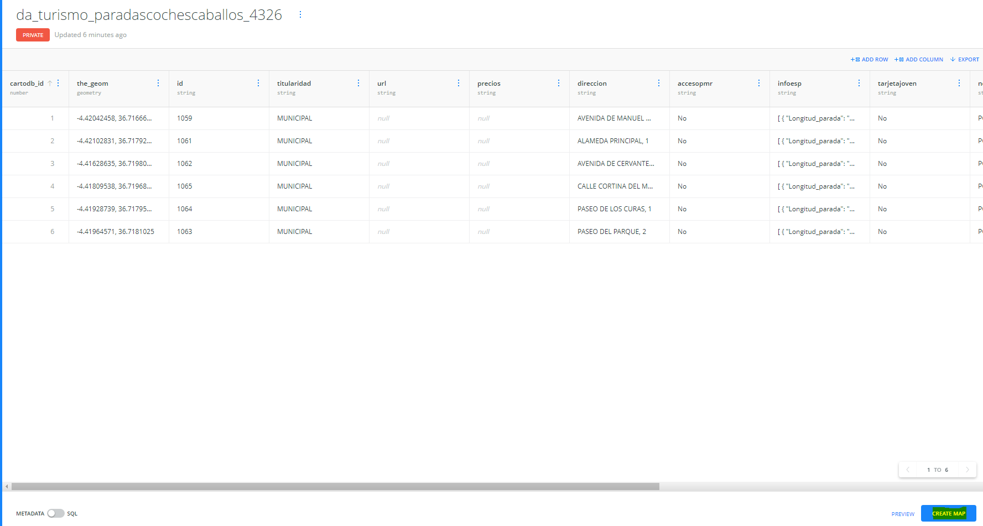

**Step 4**: Display map and legends.

